Synergistic photocatalytic conversion of lactic acid to pyruvic acid enhanced by nickel single atoms and clusters on CdS
Photocatalytic conversion of lactic acid to pyruvic acid synergistically enhanced by nickel single atoms and clusters on CdS
Yuan Xiang⁺, Hui Yang⁺, Yue Liu, Fei Huang, Xiaobin Xie*, Pengju Ren*, Fan Zhang*
[*] Y. Xiang, Y. Liu, F. Huang, F. Zhang
National Engineering Laboratory of Eco-Friendly Polymeric Materials, Key Laboratory of Green Chemistry and Technology of Ministry of Education College of Chemistry, Sichuan University
Chengdu, 610064, P. R. China
E-mail: fanzhang@scu.edu.cn
X. Xie
Analytical & Testing Center, Sichuan University
Chengdu, 116023, P. R. China
- mail: xb.xie@hotmail.com
H. Yang, P. Ren
State Key Laboratory of Coal Conversion, Institute of Coal Chemistry, Chinese Academy of Sciences
Taiyuan, 030001, P. R. China
Synfuels China Technology Co., Ltd.
Beijing, 100000, P. R. China
E-mail: renpengju@synfuelschina.com.cn
[⁺] These authors contributed equally: Yuan Xiang, Hui Yang.
Abstract
Metals supported in the forms of single atoms, clusters and particles can jointly influence the activity of supported heterogeneous catalysts. Nevertheless, the correlation between the photoelectronic characteristics of supported metals and their catalytic activity have not received sufficient attention. Furthermore, the mechanisms by which single atoms and clusters operate independently and synergistically remains poorly understood. In this study, we synthesized a high-performance, low-metal-loaded atomic-dispersed 0.3 wt% Ni/CdS nanorods (NR) photocatalyst, as well as 6.1 wt% Ni/CdS NR which simultaneously contains Ni single atoms and NiO clusters. In the photothermal catalytic conversion reaction of lactic acid, the 6.1 wt% Ni/CdS NR exhibits dual active sites and achieves high pyruvate selectivity (86.63%) and a relatively high apparent quantum yield (74.9%, λ=500 nm). Photoelectrochemical tests reveal that the separation efficiency of electrons and holes is not the main reason for the excellent catalytic activity. Density functional theory (DFT) calculations indicate that the introduction of Ni on CdS NR alters the density of S-2p orbital, which significantly enhances the dehydrogenation activity by strengthening hydrogen adsorption. Combined with electron paramagnetic resonance (ESR) results show that NiO clusters enhance the adsorption and surface concentration of the reaction substrates. The NiO/CdS interface sites and Ni single atom sites provide activation sites for C-H and O-H bond cleavage, synergistically enhancing the catalytic activity for the lactic acid reaction. This work highlights the significant synergistic effects of single atoms and clusters in improving photocatalytic performance, offering new insights for the rational design of highly efficient photocatalyst.
Introduction
The efficient conversion of waste organics into hydrogen and valuable chemicals particularly through the utilization of solar energy, represents a promising strategy for enhancing carbon resource recycling and minimizing ecological impact. ^{1–8} A key feedstock in this process is lactic acid (LA), which can be derived from the degradation of waste polylactic acid (PLA) plastics or through the fermentation of biomass sources such as corn or sugarcane. As a versatile intermediate, lactic acid plays a crucial role in producing biodegradable plastics, pharmaceuticals, and agrochemicals. ⁹ Recent advancements have demonstrated that lactic acid can be photo-catalyzed to yield hydrogen and a range of organic chemicals, including formic acid, aldehydes, and pyruvic acid, highlighting the synergy between waste conversion and the principles of a circular economy. ^{10,11} However, compared with thermal catalytic or reforming paths, the efficiency of the process is still low and far from industrialization.
To enhance the efficiency of this process, the effective separation and transport of charge carriers achieved by modification of the photocatalyst. ^{12–15} For instance, the defect-rich chalcogenide nanosheet-coupled photocatalyst d-NiPS₃/CdS rapidly extracted and transferred electrons, coupled with photo-oxidation, achieving an ultrahigh H₂ evolution rate of 39.8 mmol ∙ g_{c}ₐ_{t}⁻¹ ∙ h⁻¹, with a pyruvate production rate of 7.1 mmol ∙ g_{c}ₐ_{t}⁻¹ ∙ h⁻¹. ¹⁶ Furthermore, by integrating external heating with photocatalysis¹⁰, we optimized the charge balance between photoreduction and oxidation half-reactions, enabling the highly selective upgrading of lactic acid into hydrogen and pyruvic acid. Although these approaches have proven highly effective, they pose significant challenges in elucidating structure-activity relationship. The simultaneous variation of multiple factors induced by structural modifications of the catalyst makes it particularly difficult to identify the determining factor.
In the photocatalytic systems constructed by photocatalysts and cocatalyst, where the investigation of multi-site synergistic interactions has emerged as a focal point in catalytic research subject. For instance, Song et al. demonstrated that atomically dispersed Pt cocatalyst in Pt(II)/CdS facilitate the activation of the hydroxyl group in LA, lowering the activation barrier for PyA formation, whereas Pt nanoparticles on CdS selectively generate tartaric acid derivatives through C-C coupling. ¹⁷ Moreover, recent studies indicate that the photocatalytic activity for hydrogen evolution from water or methanol can be further enhanced when noble-metal single-atom catalysts (SACs) coexist with their nanoparticles (NPs) or nanoclusters (NCs) on CdS photocatalyst, thanks to the synergistic catalytic effects of the supported metals. ^{18,19} The above-mentioned studies exploration of these photocatalysts opens up new avenues for effective substrate adsorption and activation. However, the mechanistic elucidation of these cooperative phenomena remains particularly challenging due to the complex interfacial dynamics and competing reaction pathways involved. Hence, further investigate the complex synergistic interactions between different metal species across various photocatalytic reactions was important. Additionally, to develop a more economically viable approach, there is a need to create non-noble metal active site catalysts capable of promoting photothermal reduction and oxidation processes synergistically.
Herein, we showed successful dehydrogenation of lactic acid to pyruvic acid and hydrogen using 6.1 wt% Ni/CdS nanorods as the photocatalyst with near-zero carbon dioxide emissions, achieving a pyruvic acid selectivity of 86.63%, while producing hydrogen (H₂) with an apparent quantum yield (AQY) of 74.9% at 500 nm. Both atomically dispersed and clustered nickel oxide were observed on the CdS nanorods, which can synergistically promote the photothermal catalysis of lactic acid dehydrogenation. Electron paramagnetic resonance (ESR) results combine with density functional theory (DFT) calculations indicated that NiO clusters can promote the adsorption of LA, and single atom Ni can also provide new sites for H. The collaborative action of the two Ni forms provides activation sites for the cleavage of C-H and O-H bonds, thereby amplifying the catalytic efficiency for the lactic acid reaction. This research underscores the significance of capitalizing on the complexity of supported metals to facilitate the co-production of hydrogen and value-added chemicals via photothermal catalysis.
Results and Discussion
Cadmium sulfide nanorods (CdS NR) were synthesized through a solvothermal method, ²⁰ and various metals (Fe, Co, Ni, Cu, Pd, Pt) were deposited onto the CdS NR via photo-deposition in sodium sulfite solution, ¹⁷ resulting in metal-CdS NR photocatalysts (Scheme S1). The actual loading of the metals was quantified using inductively coupled plasma atomic emission spectrometry (ICP-AES), and all catalysts exhibited metal loading in the range of 0.3-0.5 wt% (Table S1). The catalytic performance of these catalysts in the photothermal catalytic conversion of lactic acid (LA) at 50℃ was assessed by monitoring the rates of H₂ and pyruvic acid (PyA) generation. As illustrated in Figure 1a, the rates of hydrogen evolution and PyA production followed the order: Ni > Fe > Pt > Pd > bare CdS > Cu > Co. A series of Ni-CdS catalysts with varying metal loading were synthesized, revealing a gradual increase in catalytic activity with higher metal loading. However, no significant change in activity was observed when the nickel content was increased from 6.1 wt% to 8.4 wt%, as depicted in Figure 1b. Based on these results, 6.1 wt% Ni/CdS nanorods (NR) were chosen for further investigation, while 0.3 wt% Ni/CdS NR served as a reference for comparative analysis.
To elucidate the effects of light and heat on catalytic activity, we performed lactate conversion reactions under three conditions: thermal (50 °C), photocatalytic (room temperature), and photothermal (50°C). The experimental results demonstrated that the photothermal catalytic activity of Ni/CdS NR exceeded both thermal and photocatalytic catalysis, with thermal catalysis showing negligible activity (Figure S1). The apparent quantum yield (AQY) of hydrogen production from LA under photothermal conditions at various wavelengths followed the trend observed in the UV–vis absorption spectra (solid line in Figure 1c, confirming the heat-assisted photocatalysis. Under monochromatic light at λ = 500 nm, the AQY for the 0.3 wt% Ni/CdS NR catalyst reached a maximum of 28.1%, while for the 6.1 wt% Ni/CdS NR catalyst, it increased to 74.9%, highlighting the enhanced photon utilization efficiency in the light-driven photocatalytic LA conversion process.
A consecutive 35-hour activity test was conducted to assess the catalytic stability of the 6.1 wt% Ni/CdS NR catalyst under photothermal conditions (Figure 1d). The catalytic activity slightly decreased during the third cycle due to the depletion of LA, but was fully restored in the fourth cycle upon replenishing LA, confirming the excellent stability of the catalyst under photothermal conditions. LA conversion, hydrogen and pyruvic acid (PyA) production, and PyA selectivity in the liquid products during the reaction are shown in Figure 1e. After 4 hours, the 6.1 wt% Ni/CdS NR catalyst converted 2.91 mmol of LA, with a PyA selectivity of 92.05% (detailed liquid product information is provided in Figure S2). After 21 hours of reaction, LA conversion efficiency reached 86.6%, yielding 10.06 mmol of hydrogen and 7.49 mmol of PyA. Notably, under light irradiation at 50°C, the hydrogen production rate was 37.83 mmol∙g⁻¹_{cat}∙h⁻¹, and the PyA production rate was 27.23 mmol∙g⁻¹_{cat}∙h⁻¹. The hydrogen production rate was comparable to the highest results from previous studies, while the PyA production rate was 5 to 20 times higher than previous reports (Figure 1f).
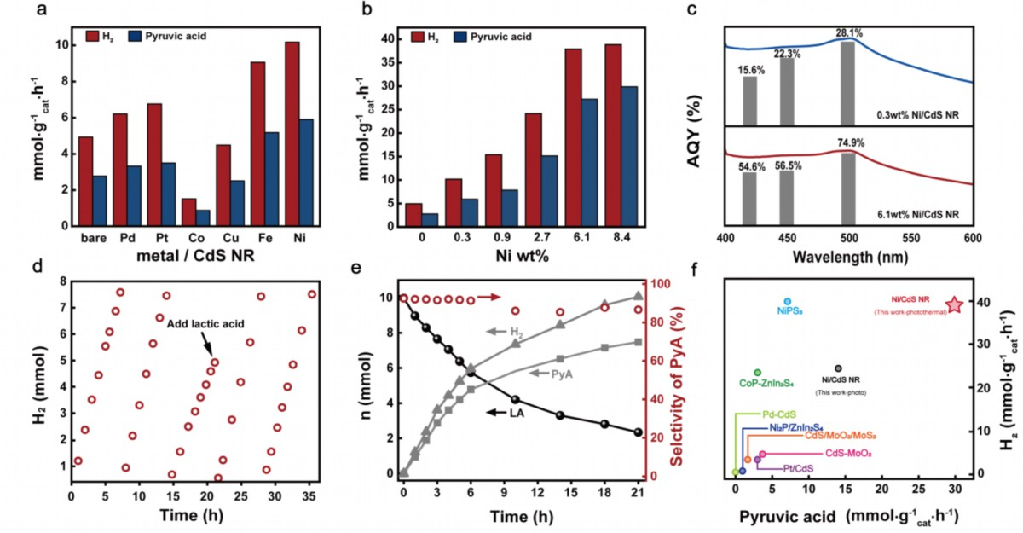
Figure 1. Catalytic performances of metal-CdS nanorods (NR). Pyruvic acid and H₂ production rate over metal-CdS catalysts with (a) different types of metal (b) different loading of Ni under light irradiation. (c) Apparent quantum yield (AQY) of Ni/CdS catalysts at 420 nm, 450 nm, 500 nm. (d) Stability of 6.1 wt% Ni/CdS NR. (e) Time course of hydrogen and liquid product contents during the photocatalytic reaction over 6.1wt% Ni/CdS NR. Reaction conditions: 30 mg photocatalyst, 30 mmol lactic acid, 40 mL H₂O, T = 50 ℃, and He. (f) Hydrogen and pyruvic acid performance compared with others catalysts. (Reference was listed in Table S2)
Structural and Morphological Characterizations of Ni/CdS Photocatalyst.
To elucidate the origin of the excellent catalytic activity of the Ni/CdS NR catalyst, scanning transmission electron microscopy (STEM) technology was employed to investigate the morphology and crystal structure of the CdS-based catalysts. Figure S3 shows that the CdS nanorods exhibited a rod-like morphology with a lattice spacing of 0.342 nm, corresponding to the (002) crystal planes of hexagonal CdS. Spherical aberration corrected scanning transmission electron microscopy (SAC-STEM), high-angle annular dark field scanning transmission electron microscopy (HAADF-STEM) and energy-dispersive X-ray (EDX) mapping reveal that Ni in 0.3 wt% Ni/CdS NR was uniformly dispersed. In contrast, for the 0.9 wt% Ni/CdS NR, metal aggregation into clusters was observed, with both the size and number of clusters increasing as the metal loading rose (Figure S4-S7). Figure 2a, 2c, 2d and S8 show detailed characterizations of TEM, HAADF-STEM, and STEM-EDX elemental mapping images for the 6.1 wt% Ni/CdS NR catalyst, where the majority of Ni was highly dispersed, along with some Ni metal particles. High-resolution TEM (HRTEM) image (Figure 2b) and selected-area electron diffraction (SAED) images (Ⅰ, Ⅱ) were demonstrated that NiO nanoparticles exhibited high crystallinity, showing well-defined lattice fringes with an interplanar spacing of 0.204 and 0.241 nm that can be ascribed to the (200) and (111) planes of NiO, ²¹ respectively. To examine the atomic structure and distribution of Ni atoms in the 6.1 wt% Ni/CdS NR, HAADF-STEM with atomic resolution was employed on a localized region (Figure 2e). By comparing the element-specific electron scattering cross-sections (scattering ∝ Z^{1.5~2}) for Ni (Z=28) and Cd (Z=48), ²² it was determined that Ni atoms replaced Cd atoms (inset of Figure 2e), which may contribute to the enhancement of catalytic performance.
The crystal structure of the as-prepared samples was characterized by X-ray diffraction (XRD) (Figure S9). The XRD peaks of both Ni/CdS NR composites and pure CdS NR (Figure 2f) were in excellent agreement with the hexagonal phase (JCPDS 41-1049), confirming that the Ni/CdS composites retained the hexagonal CdS structure. ²³ The local structure of Ni species in 0.3 wt% Ni/CdS NR and 6.1 wt% Ni/CdS NR were further investigated via X-ray absorption spectroscopy (XAS), with Ni foil and NiO serving as references. As shown in Figure 2g, the energy edge of Ni in 0.3 wt% Ni/CdS NR and 6.1 wt% Ni/CdS NR was much higher than that of Ni foil but slightly lower than that of NiO, suggesting that the valence state of Ni was nearly +2. The near-edge absorption of 6.1 wt% Ni/CdS NR was closer to that of the NiO, implying the valence state of Ni in this sample was more similar to that of NiO due to the formation of nickel oxide clusters.
The Fourier-transformed (FT) Ni K-edge extended X-ray absorption fine structures (EXAFS) spectra shown in Figure 2h reveal that 6.1 wt% Ni/CdS NR had one primary peak corresponding to the Ni-O-Ni scattering path at 2.6 Å and a shoulder peak corresponding to the Ni-O scattering path at around 1.6 Å (without phase correction, unless stated). ^{24,25} The 0.3 wt% Ni/CdS NR catalysts exhibit first shell scattering at approximately 1.6 Å in R space, which was in close proximity to that in NiO. The absence of Ni-O-Ni and Ni-Ni peaks further supports the atomic dispersion of Ni with CdS NR,^{26,27} consistent with the findings from the HAADF-STEM imaging. The corresponding Ni K-edge EXAFS fitting of 0.3 wt% Ni/CdS NR reveals a Ni-O coordination number of 6.0, with a bond length of approximately 2.05 Å was shown in Table S3. Meanwhile, the bond of Ni-O-Ni was observed in the second shell of 6.1 wt% Ni/CdS NR, confirmed the existence of NiO nanoparticles. And the average coordination numbers (CN) of Ni-O-Ni was 1.5, suggesting the formation of small Ni cluster and nanoparticles.²⁸ The oscillating frequencies and shapes of the k³χ(k) oscillation curves at the Ni K-edge of 6.1 wt% Ni/CdS NR were similar from NiO (Figure S10).
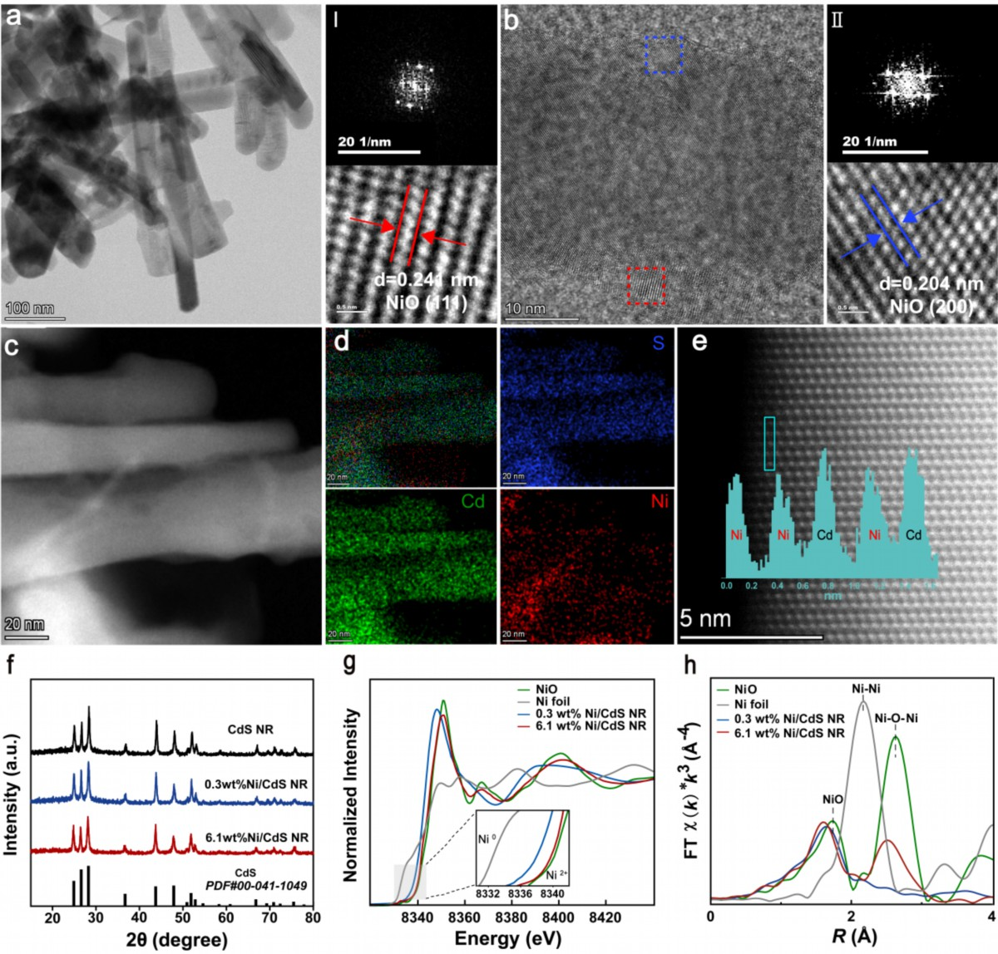
Figure 2. Structural characterizations of 6.1 wt% Ni/CdS NR catalysts. (a) Transmission electron microscope (TEM) image. (b) High-resolution TEM (HRTEM) images, Ⅰ, Ⅱ: selected-area electron diffraction (SAED) images of NiO. (c) High angle annual dark field scanning electron microscope (HAADF-STEM) and (d) STEM energy-dispersive X-ray (STEM-EDX) elemental mapping images. (d) Atomic resolution HAADF-STEM image and brightness intensity of the line profile with a single site as the green-frame. (f) X-ray diffraction (XRD) of CdS catalysts. (g) X-ray absorption near edge structure (XANES) spectra. (h) Extended X-ray Absorption Fine Structure (EXAFS) spectra.
The enhanced electron transfer capability of the Ni/CdS NR catalyst was substantiated by photocurrent, electrochemical impedance spectroscopy (EIS), and photoluminescence (PL) spectroscopy. As displayed in Figure 3a, the charge transfer ability improved after Ni was loaded onto CdS NR. The EIS data in Figure 3b further indicate that the incorporation of cocatalysts reduced charge transfer resistance, thereby enhancing the carrier transport efficiency. However, a decline in photoelectrochemical performance was observed at 6.1 wt% Ni/CdS NR.²⁹ Therefore, we established a correlation between the hydrogen evolution activity and the current density for diverse catalyst loading. Figure 3c provides clear evidence that the enhanced photoelectrochemical activity observed in the 6.1 wt% Ni/CdS NR was not a coincidental phenomenon. Fluorescence spectroscopy analysis further provides insights into the charge transfer dynamics within the Ni/CdS NR system. As depicted in Figure S11, the Ni/CdS NR displayed a distinct PL emission peak at approximately 520 nm. This peak is characteristic of the recombination of photogenerated electron-hole pairs. Previous studies ^{30–32} have shown that a lower PL peak intensity in the case of CdS implies more efficient charge transfer. In the Ni/CdS system, the reduction in the PL peak intensity of CdS indicates that electrons can be transferred more effectively from the CdS NR to Ni. This enhanced charge transfer promotes the separation of charge carriers, ultimately leading to an improvement in the photothermal catalytic efficiency. Time-resolved photoluminescence (TRPL) spectroscopy (Figure S12) was employed to investigate the charge carrier dynamics of CdS and Ni/CdS catalysts. Specifically, the loading of Ni results in a decrease in the average emission lifetime, signifying the inter-band recombination is suppressed due to the establishment of charge transfer channels. Concurrently, the improved charge separation efficiency allowed more electrons to reach the surface of the photocatalyst for proton reduction and H₂ generation. Notably, the fluorescence intensity and average emission lifetime trends of the catalysts were consistent. This finding indicates that the catalytic performance of this material was not solely dependent on the photo-electrical activity, highlighting the complexity of the underlying mechanism.
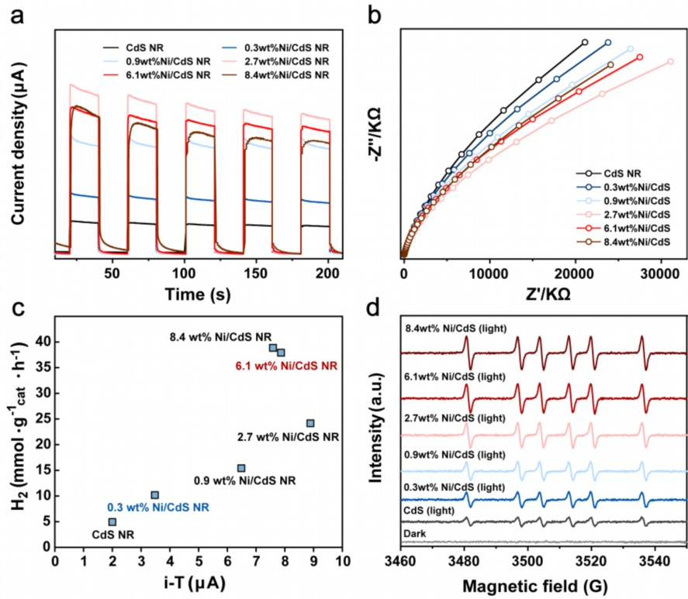
Figure 3. (a) Transient photocurrent response (TPR), (b) Electrochemical impedance spectroscopy (EIS), (c) Correlation plot of photocurrent and activity over Ni/CdS NR catalysts with different Ni loading under light irradiation. (d) In situ ESR spectra of as-synthesized samples 5,5-Dimethyl-1-pyrroline N-oxide (DMPO) in the dark and light irradiation.
In situ Electron spin resonance (ESR) spectroscopy was conducted to quantify the concentration of major radical intermediates involved in LA oxidation reaction over Ni/CdS NR via using 5,5-Dimethyl-1-pyrroline N-oxide (DMPO) as spin trap agent. In Figure 3d, six characteristic peaks indicative of carbon-centered radicals were observed in all Ni/CdS NR catalysts, which confirmed the formation of LA-derived carbon-centered radicals (∙C₃H₅O₃). As the metal loading increases, the concentration of radical intermediates continuously rises. However, the 8.4 wt% Ni/CdS NR exhibits a similar radical level to that of the 6.1 wt% Ni/CdS NR, and this situation is consistent with the catalytic.
Density functional theory (DFT) calculations were performed to explore the role of Ni on LA conversion process and reveal the effects of Ni loading on reaction mechanism. Prior characterization results indicate that low-load Ni predominantly exists in the form of single atoms, while high-load Ni manifests as nickel oxide clusters accompany with Ni single atoms. Herein, we modeled these two states as Ni-doped CdS (110) surfaces (designated as Cd(Ni)S) and NiO nanobelts supported on doped-Cd(Ni)S (110) surface (denoted as NiO/Cd(Ni)S). These models represent two forms of Ni loading, highlighting the Ni single-atom sites and the NiO/Cd(Ni)S composite interfacial sites while maintaining computational efficiency. The optimized structures were shown in Figure 4a. In the Ni-doped model, we evaluated various potential doping sites, ultimately determining that the substitution of surface cadmium (Cd) by Ni is the most thermodynamic favorable, consistent with the STEM results (Figure S13).
The oxidation of LA into pyruvic acid involves several critical steps: adsorption of the reactant, activation and cleavage of C-H and O-H bonds, and subsequent desorption of products. Consequently, the stability of key reaction species is vital for optimizing reaction performance. As shown in Figure 4b and Figure S14, we systemically compared the formation energies of reaction species on pristine CdS site, Cd(Ni)S and NiO/CdS sites. For the adsorption of C₃H₆O₃ molecule, the Ni-doped CdNiS model slightly improve the adsorption strength compared to pure CdS surface (-0.24 vs. -0.22 eV), while NiO/Cd(Ni)S improve the adsorption strength more significantly due to the presence of oxygen vacancy at the interface (-0.84 vs. -0.22 eV). In addition, low loading of Ni has a very weak effect on the adsorption energy of C3H5O3 intermediate (0.35 vs. 0.41 eV), while the NiO/Cd(Ni)S interface site still shows a significantly enhanced stabilization effect (0.35 vs. 0.04 eV). All of these show that NiO/Cd(Ni)S can enrich the reactant concentration under a stronger activation ability, which will beneficial to the whole reaction and consistent with the phenomena observed in ESR spectra.
For another key species for dehydrogenation reaction, adsorbed H, Figure 4b shows that the introduction of Ni atoms provides new H adsorption sites with the adsorption energies of 0.2 and 0.35 eV, respectively. However, the adsorption of H on the Cd site are all very weak and are not affected by Ni, which means that Cd site is not the site for H. While for S sites, the adsorption of H is enhanced from 0.8 to -0.07 and -0.29 eV for Cd(Ni)S and NiO/Cd(Ni)S, respectively. The above analysis shows that due to the very weak hydrogen adsorption energies on the CdS surface, it is not conducive to the activation and dissociation of C-H and O-H bonds. However, the introduction of Ni greatly enhances the hydrogen adsorption energy on surface S site, and introduces new adsorption sites, thereby enhancing the catalytic performance. The electronic structure analysis in Figure S15 reveals that both the Ni substitution and supported NiO cluster increase the density of p states for S sites near Fermi level, which leads to the increase in the binding energy of H atoms increases. Furthermore, Ni doping introduces new mid-states above the Fermi level, adjacent to the valence band (VB), which facilitates the efficient capture of photogenerated holes.
Figure 4c reveals the role of two forms of Ni in regulating the reaction pathway. Compared with CdS nanorods, the enhanced adsorption of H by the Cd(Ni)S system significantly reduces the potential energy of the two H-breaking steps (0.93 eV → 0.41 eV, 2.27 → 1.04 eV), indicating that Ni doping effectively promotes the dehydrogenation process of the reaction. The co-enhanced adsorption of H and surface C species by the NiO/Cd(Ni)S system shows a lowest potential energy in the entire reaction pathway, which is significantly better than Cd(Ni)S and CdS, reflecting that the synergistic effect of NiO clusters and Ni doping further reduces the energy cost.
The synergistic mechanism involving the Ni single-atom sites and NiO/Cd(Ni)S interfacial sites is illustrated in Figure 4d. As shown, the interface sites enhance the adsorption strength and surface concentration of the reactants. In addition, the Ni single atoms also synergistically enhance the strength of the surface H species and promote the breaking process of C-H and O-H bonds. This synergistic interaction significantly enhances the catalytic activity during the photocatalytic LA conversion process.
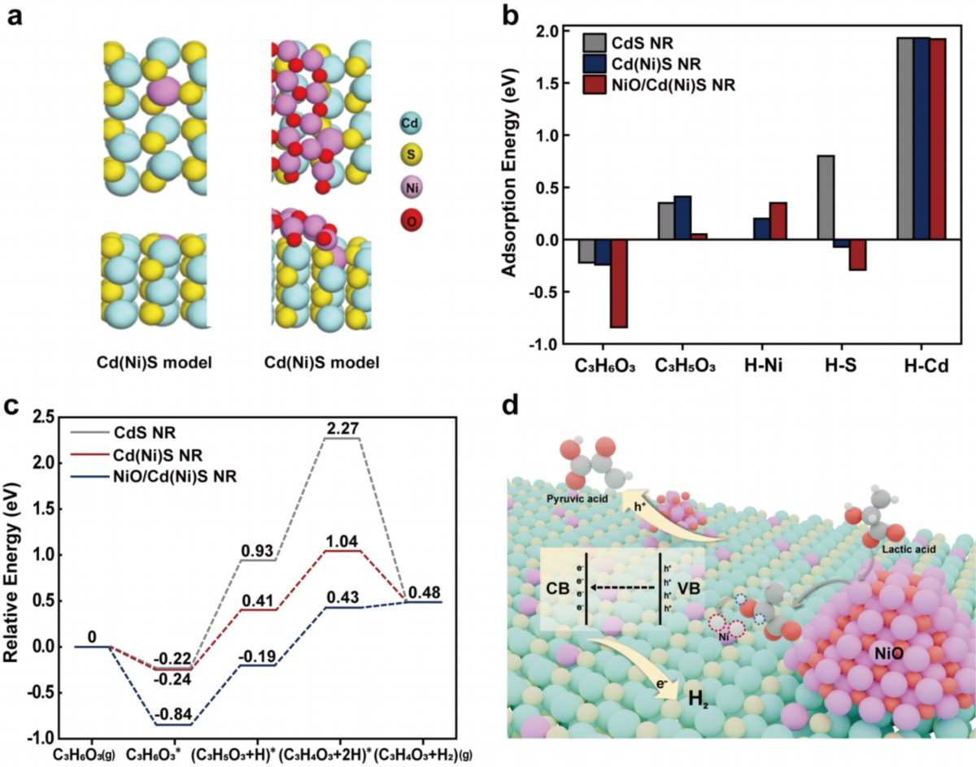
Figure 4. DFT calculations on the mechanism of lactic acid to pyruvic acid over Ni/CdS catalysts. (a) Optimized structures of Ni single atoms (Cd(Ni)S model) and NiO nanocluster supported on Ni-doped CdS (110) surface (NiO/Cd(Ni)S model). (b) Formation energies of the key reaction species on pristine CdS NR surface, Cd(Ni)S NR surface and NiO/Cd(Ni)S NR surface. (c) Energy diagram for catalytic LA oxidation. X-axis illustrates the reaction coordination; Y-axis illustrates the relative energy of each step. (d) Schematic illustration of the synergistic mechanism over Ni single atoms site and NiO/CdS interface site.

Conclusion
In summary, we have achieved remarkable LA conversion to PyA and H₂ over a non-noble metal photocatalyst, Ni/CdS. The photocatalyst, featuring both Ni single atoms and NiO clusters over CdS, demonstrates superior photothermal catalytic activity attributed to the significant synergy between these components. NiO clusters enhance the adsorption and dissociation of LA molecules, in conjunction with Ni single atoms provide activation sites for C-H and O-H bond cleavage. This study provides valuable insights into the synergistic interactions between single atoms and nanoscale entities, contributing to enhanced photocatalytic performance and offering new directions for the rational design of highly efficient photocatalysts.
Reference
(1) Ouyang, Z.; Yang, Y.; Zhang, C.; Zhu, S.; Qin, L.; Wang, W.; He, D.; Zhou, Y.; Luo, H.; Qin, F. Recent Advances in Photocatalytic Degradation of Plastics and Plastic-Derived Chemicals. J. Mater. Chem. A 2021, 9 (23), 13402–13441. https://doi.org/10.1039/D0TA12465F.
(2) Han, M.; Zhu, S.; Xia, C.; Yang, B. Photocatalytic Upcycling of Poly(Ethylene Terephthalate) Plastic to High-Value Chemicals. Appl. Catal. B: Environ. 2022, 316, 121662. https://doi.org/10.1016/j.apcatb.2022.121662.
(3) Du, M.; Zhang, Y.; Kang, S.; Guo, X.; Ma, Y.; Xing, M.; Zhu, Y.; Chai, Y.; Qiu, B. Trash to Treasure: Photoreforming of Plastic Waste into Commodity Chemicals and Hydrogen over MoS₂-Tipped CdS Nanorods. ACS Catal. 2022, 12 (20), 12823–12832. https://doi.org/10.1021/acscatal.2c03605.
(4) Uekert, T.; Pichler, C. M.; Schubert, T.; Reisner, E. Solar-Driven Reforming of Solid Waste for a Sustainable Future. Nat. Sustain. 2020, 4 (5), 383–391. https://doi.org/10.1038/s41893-020-00650-x.
(5) Zhao, L.; Dong, T.; Du, J.; Liu, H.; Yuan, H.; Wang, Y.; Jia, J.; Liu, H.; Zhou, W. Synthesis of CdS/MoS₂ Nanooctahedrons Heterostructure with a Tight Interface for Enhanced Photocatalytic H₂ Evolution and Biomass Upgrading. Sol. RRL 2021, 5 (2), No. 2000415. https://doi.org/10.1002/solr.202000415.
(6) Li, Y.; Wan, S.; Lin, C.; Gao, Y.; Lu, Y.; Wang, L.; Zhang, K. Engineering of 2D/2D MoS₂ /Cd _{x} Zn _{1− x} S Photocatalyst for Solar H₂ Evolution Coupled with Degradation of Plastic in Alkaline Solution. Solar RRL 2021, 5 (6), 2000427. https://doi.org/10.1002/solr.202000427.
(7) Sun, C.; Wei, S.; Tan, H.; Huang, Y.; Zhang, Y. Progress in Upcycling Polylactic Acid Waste as an Alternative Carbon Source: A Review. Chem. Eng. J. 2022, 446, 136881. https://doi.org/10.1016/j.cej.2022.136881.
(8) Vaidya, A. N.; Pandey, R. A.; Mudliar, S.; Kumar, M. S.; Chakrabarti, T.; Devotta, S. Production and Recovery of Lactic Acid for Polylactide-An Overview. Crit. Rev. Env. Sci. Tec. 2005, 35 (5), 429–467. https://doi.org/10.1080/10643380590966181.
(9) Feng, S.; Nguyen, P. T. T.; Ma, X.; Yan, N. Photorefinery of Biomass and Plastics to Renewable Chemicals Using Heterogeneous Catalysts. Angew. Chem. Int. Ed. 2024, 63 (37), No. e202408504. https://doi.org/10.1002/anie.202408504.
(10) Xiang, Y.; Zhang, J.; Huang, F.; Xiao, N.; Fan, Y.; Zhang, J.; Zheng, H.; Chen, J.; Zhang, F. One-Pot Photothermal Upcycling of Polylactic Acid to Hydrogen and Pyruvic Acid. Chin. J. Catal. 2024, 59, 149–158. https://doi.org/10.1016/S1872-2067(23)64638-8.
(11) Qi, M.-Y.; Conte, M.; Anpo, M.; Tang, Z.-R.; Xu, Y.-J. Cooperative Coupling of Oxidative Organic Synthesis and Hydrogen Production over Semiconductor-Based Photocatalysts. Chem. Rev. 2021, 121 (21), 13051–13085. https://doi.org/10.1021/acs.chemrev.1c00197.
(12) Xiao, J.; Vequizo, J. J. M.; Hisatomi, T.; Rabeah, J.; Nakabayashi, M.; Wang, Z.; Xiao, Q.; Li, H.; Pan, Z.; Krause, M.; Yin, N.; Smith, G.; Shibata, N.; Brückner, A.; Yamakata, A.; Takata, T.; Domen, K. Simultaneously Tuning the Defects and Surface Properties of Ta₃N₅ Nanoparticles by Mg-Zr Codoping for Significantly Accelerated Photocatalytic H₂ Evolution. J. Am. Chem. Soc. 2021, 143 (27), 10059–10064. https://doi.org/10.1021/jacs.1c04861.
(13) Xu, R.; Liu, W.; Deng, Y.; Gao, R.; Huang, N.; Zheng, Y.; Huang, Y.; Ye, L. Simultaneously Regulating Charge Separation and Proton Supply-Demand in Polyphenol Amine for Hydrogen Peroxide Photosynthesis. Chem. Eng. J. 2024, 486, No. 150137. https://doi.org/10.1016/j.cej.2024.150137.
(14) Luo, J.; Zhu, C.; Li, J.; Jin, J.; Soland, N. E.; Smith, P. W.; Shan, Y.; Oddo, A. M.; Maulana, A. L.; Jayasinghe, L.; Chen, X.; Wang, T.; Lin, J.-A.; Lu, E.; Schaefer, B.; Schmalzbauer, M.; Zhang, R.; Seeler, F.; Lizandara-Pueyo, C.; Guo, J.; Yang, P. Photocatalytic Methanol Dehydrogenation with Switchable Selectivity. J. Am. Chem. Soc. 2025, 147 (4), 3428–3437. https://doi.org/10.1021/jacs.4c14413.
(15) Altomare, M.; Qin, S.; Saveleva, V. A.; Badura, Z.; Tomanec, O.; Mazare, A.; Zoppellaro, G.; Vertova, A.; Taglietti, A.; Minguzzi, A.; Ghigna, P.; Schmuki, P. Metastable Ni(I)-TiO_{2-x} Photocatalysts: Self-Amplifying H₂ Evolution from Plain Water without Noble Metal Co-Catalyst and Sacrificial Agent. J. Am. Chem. Soc. 2023, 145 (48), 26122–26132. https://doi.org/10.1021/jacs.3c08199.
(16) Zhang, S.; Li, H.; Wang, L.; Liu, J.; Liang, G.; Davey, K.; Ran, J.; Qiao, S.-Z. Boosted Photoreforming of Plastic Waste via Defect-Rich NiPS₃ Nanosheets. J. Am. Chem. Soc. 2023, 145 (11), 6410–6419. https://doi.org/10.1021/jacs.2c13590.
(17) You, Y.; Han, P.; Song, S.; Luo, W.; Zhao, S.; Han, K.; Tian, Y.; Yan, N.; Li, X. Distinct Selectivity Control in Solar-Driven Bio-Based α-Hydroxyl Acid Conversion: A Comparison of Pt Nanoparticles and Atomically Dispersed Pt on CdS. Angew. Chem. Int. Ed. 2023, 62 (43), No. e202306452. https://doi.org/10.1002/anie.202306452.
(18) Gao, Z.; Montini, T.; Mu, J.; Luo, N.; Fonda, E.; Fornasiero, P.; Wang, F. Photocatalytic Methanol Dehydrogenation Promoted Synergistically by Atomically Dispersed Pd and Clustered Pd. J. Am. Chem. Soc. 2024, 146 (35), 24440–24449. https://doi.org/10.1021/jacs.4c06573.
(19) Zhang, J.; Pan, Y.; Feng, D.; Cui, L.; Zhao, S.; Hu, J.; Wang, S.; Qin, Y. Mechanistic Insight into the Synergy between Platinum Single Atom and Cluster Dual Active Sites Boosting Photocatalytic Hydrogen Evolution. Adv. Mater. 2023, 35 (25), No. 2300902. https://doi.org/10.1002/adma.202300902.
(20) Jang, J. S.; Joshi, U. A.; Lee, J. S. Solvothermal Synthesis of CdS Nanowires for Photocatalytic Hydrogen and Electricity Production. J. Phys. Chem. C 2007, 111 (35), 13280–13287. https://doi.org/10.1021/jp072683b.
(21) Wang, T.; Duan, X.; Bai, R.; Li, H.; Qin, C.; Zhang, J.; Duan, Z.; Chen, K.-J.; Pan, F. Ni-Electrocatalytic CO2 Reduction Toward Ethanol. Adv. Mater. 2024, 36 (44), 2410125. https://doi.org/10.1002/adma.202410125.
(22) Yuan, Q.; Gu, Y.; Chen, W.; Zhang, Y.; Song, X.; Ding, Y.; Li, X.; Zhu, L.; Jiang, Z.; Yan, L.; Ma, J.; Ding, Y. Heterogeneous Carbonylation of Alcohols on Charge-Density-Distinct Mo−Ni Dual Sites Localized at Edge Sulfur Vacancies. Angew. Chem. Int. Ed. 2024, 63 (52), No. e202411632. https://doi.org/10.1002/anie.202411632.
(23) Zhang, J.; Qiao, S. Z.; Qi, L.; Yu, J. Fabrication of NiS Modified CdS Nanorod p–n Junction Photocatalysts with Enhanced Visible-Light Photocatalytic H₂-Production Activity. Phys. Chem. Chem. Phys. 2013, 15 (29), 12088–12094. https://doi.org/10.1039/C3CP50734C.
(24) Yan, F.-Q.; Dong, X.-Y.; Wang, Y.-M.; Wang, Q.-Y.; Wang, S.; Zang, S.-Q. Asymmetrical Interactions between Ni Single Atomic Sites and Ni Clusters in a 3D Porous Organic Framework for Enhanced CO₂ Photoreduction. Adv. Sci. 2024, 11 (23), No. 2401508. https://doi.org/10.1002/advs.202401508.
(25) Fu, H. Q.; Zhou, M.; Liu, P. F.; Liu, P.; Yin, H.; Sun, K. Z.; Yang, H. G.; Al-Mamun, M.; Hu, P.; Wang, H.-F.; Zhao, H. Hydrogen Spillover-Bridged Volmer/Tafel Processes Enabling Ampere-Level Current Density Alkaline Hydrogen Evolution Reaction under Low Overpotential. J. Am. Chem. Soc. 2022, 144 (13), 6028–6039. https://doi.org/10.1021/jacs.2c01094.
(26) Xiao, M.; Zhang, L.; Luo, B.; Lyu, M.; Wang, Z.; Huang, H.; Wang, S.; Du, A.; Wang, L. Molten-Salt-Mediated Synthesis of an Atomic Nickel Co-Catalyst on TiO₂ for Improved Photocatalytic H₂ Evolution. Angew. Chem. Int. Ed. 2020, 59 (18), 7230–7234. https://doi.org/10.1002/anie.202001148.
(27) Xiong, L.; Qi, H.; Zhang, S.; Zhang, L.; Liu, X.; Wang, A.; Tang, J. Highly Selective Transformation of Biomass Derivatives to Valuable Chemicals by Single-Atom Photocatalyst Ni/TiO₂. Adv. Mater. 2023, 35 (16), No. 2209646. https://doi.org/10.1002/adma.202209646.
(28) Ge, Y.; Gao, Z.; Xu, Y.; Xu, M.; Qin, X.; Peng, M.; Wang, S.; Gao, R.; Zhou, W.; Ma, D. Inverting Methanol Dehydrogenation Selectivity by Crowding Atomic Ni Species over α-MoC Catalysts. Angew. Chem. Int. Ed. n/a (n/a), No. e202423682. https://doi.org/10.1002/anie.202423682.
(29) Liu, X.; Fan, X.; Wu, J.; Zhuge, Z.; Li, L.; Fan, J.; Shen, S.; Tang, Z.; Gong, Y.; Xue, Y.; Pan, L. CdS-Based Schottky Junctions for Efficient Visible Light Photocatalytic Hydrogen Evolution. J. Colloid Interf. Sci. 2024, 673, 1–8. https://doi.org/10.1016/j.jcis.2024.06.040.
(30) Liu, C.-X.; Liu, K.; Xu, Y.; Wang, Z.; Weng, Y.; Liu, F.; Chen, Y. Photocatalytic Upgrading of Polylactic Acid Waste into Alanine under Mild Conditions. Angew. Chem. Int. Ed. 2024, 63 (16), No. e202401255. https://doi.org/10.1002/anie.202401255.
(31) Liu, F.; Wang, Z.; Weng, Y.; Shi, R.; Ma, W.; Chen, Y. Black Phosphorus Quantum Dots Modified CdS Nanowires with Efficient Charge Separation for Enhanced Photocatalytic H₂ Evolution. ChemCatChem 2021, 13 (5), 1355–1361. https://doi.org/10.1002/cctc.202001847.
(32) Chava, R. K.; Do, J. Y.; Kang, M. Enhanced Photoexcited Carrier Separation in CdS-SnS₂ Heteronanostructures: A New 1D-0D Visible-Light Photocatalytic System for the Hydrogen Evolution Reaction. J. Mater. Chem. A 2019, 7 (22), 13614–13628. https://doi.org/10.1039/C9TA03059J.

